Đã công bố bằng Google Tài liệu

[Tìm hiểu thêm](https://support.google.com/docs/answer/183965)[Báo cáo Lạm dụng](https://docs.google.com/u/2/abuse?id=AKkXjozyTvwsJefnaCEPRRU3lgHTWE4Vm7NzX0bpiEctm1LhKjgimmdz9ytN4Axe3lwZtHaW:0)

CAU-HOI-ON-TAP-PE-NWC203c-FALL-2021.docx

Cập nhật tự động 5 phút một lần

**ĐÁP ÁN ÔN TẬP ĐỀ PE NWC203c FALL 2021 SV PHẢI LÀM TỪNG BƯỚC ĐẾN KẾT QUẢ**

**(**[**https://kaymid.notion.site/Gi-i-th-c-h-nh-b419cf5442fa43af9be4bfa492c7d1f7**](https://www.google.com/url?q=https://kaymid.notion.site/Gi-i-th-c-h-nh-b419cf5442fa43af9be4bfa492c7d1f7&sa=D&source=editors&ust=1638686248905000&usg=AOvVaw22VsuAAeGb1zyIdxfzvXTa)**)**

**1.**Suppose two hosts, A and B, are separated by 30,000 kilometers and are  connected by a direct link of *R*= 3 Mbps. Suppose the propagation speed over  the link is 2.5 x 108meters/sec.

a. Calculate the bandwidth-delay product, *R*_ *d*prop.

b. Consider sending a file of 900,000 bits from Host A to Host B. Suppose the  file is sent continuously as one large message. What is the maximum number of  bits that will be in the link at any given time?

**2.**Let g(x)=x3+x+1. Consider the information sequence 1001. Find the  codeword corresponding to the preceding information sequence. Using  polynomial arithmetic we obtain

**3.**A packet switch receives a packet and determines the outbound link to which  the packet should be forwarded. When the packet arrives, one other packet is  halfway done being transmitted on this outbound link and four other packets are  waiting to be transmitted. Packets are transmitted in order of arrival.

Suppose all packets are 2,500 bytes and the link rate is 3 Mbps. What is the  queuing delay for the packet? More generally, what is the queuing delay when all  packets have length *L*, the transmission rate is *R*, *x*bits of the currently-being transmitted packet have been transmitted, and *n*packets are already in the queue?

**4.**Suppose a header consists of four 16-bit words: (11111111 11111110,  11111111 00000000, 11110000 11110000, 11000000 11000001). Find the  Internet checksum for this code

Solution:

(4)

Given,

=>16-bit words

=>Four 16-bit words = (11111111 11111110, 11111111 00000000, 11110000 11110000, 11000000 11000001)

Explaination:

Calculating internet checksum:

Step 1:

=>Summing all the four 16-bit words

=>Summation = 1111111111111110 + 1111111100000000 + 1111000011110000 + 1100000011000001

=>Summation = 111011000010101111

Step 2:

=>Summation contains 18 bits so wrapping around extra 2 bits

=>Wrapped summation = 1011000010101111 + 11

=>Wrapped summation = 1011000010110010

Step 3:

=>Taking the 1's complement of wrapped summation

=>Internet checksum = 1's complement of wrapped summation

=>Internet checksum = 1's complement of 1011000010110010

=>Internet checksum = 0100111101001101

=>Internet checksum = 01001111 01001101

I have explained each and every part with the help of statements attached to the answer above.

**5.**Consider a packet of length 2,000 bytes that propagates over a link of  distance 3,500 km with propagation speed of 2,5 · 108m/s, and  transmission rate

2 Mbps?

a. How long does the packet propagation take?

b. Does this propagation delay depend on the packet length?

c. Does this propagation delay depend on the transmission rate?

Bổ sung câu a

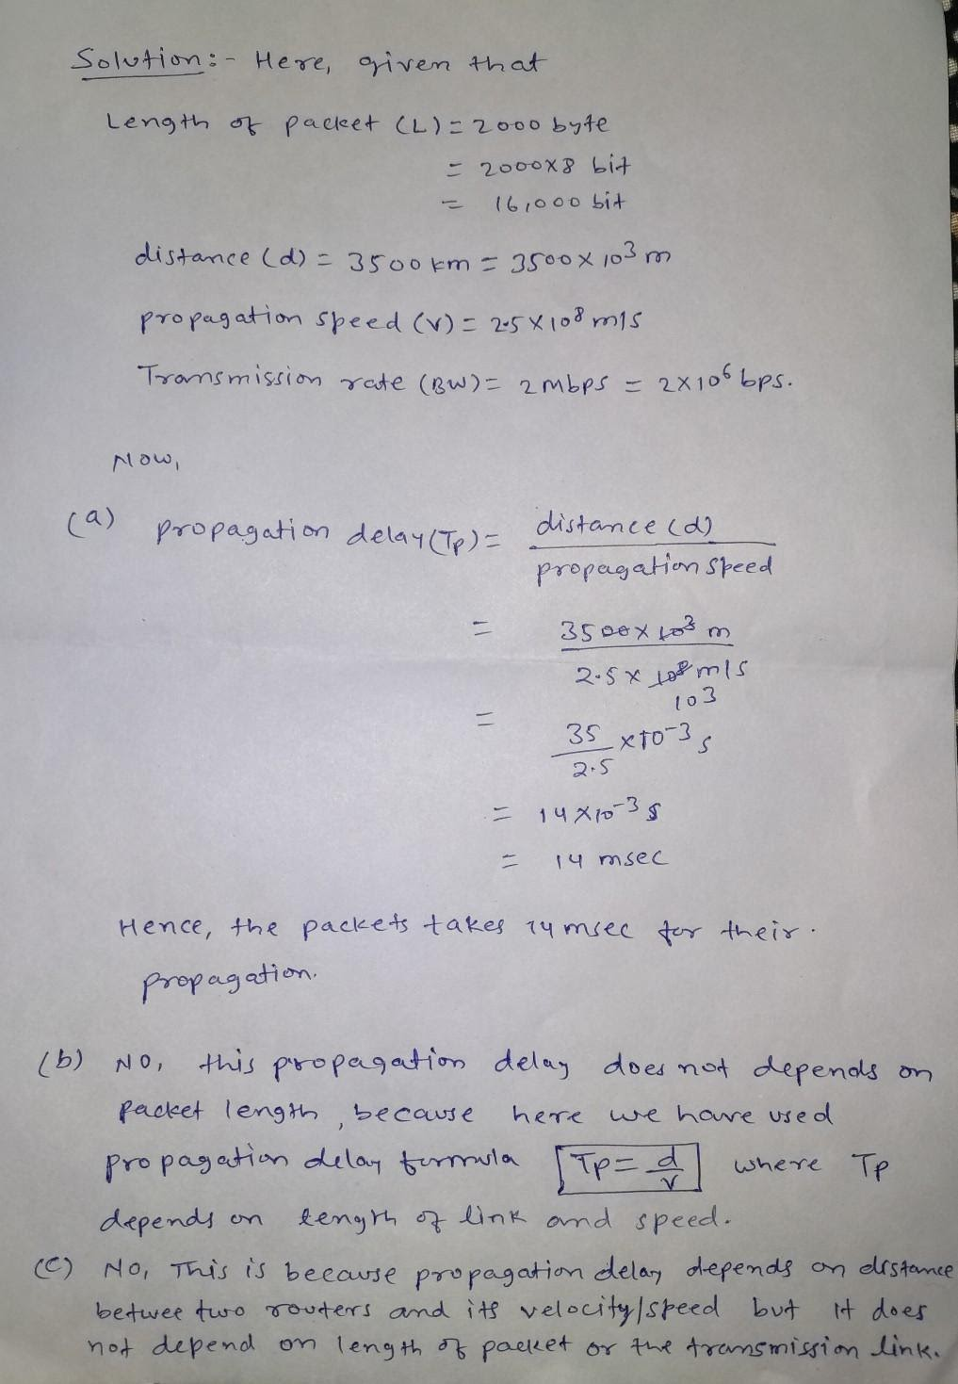

**6.**A router has the following CIDR entries in its routing table: *Address/mask Next hop*

135.46.56.0/22 Interface 0

135.46.60.0/22 Interface 1

192.53.40.0 /23 Router 1

default Router 2

(a) What does the router do if a packet with an IP address 135.46.63.10  arrives?

(b)What does the router do if a packet with an IP address 135.46.57.14  arrives?

Consider the following entries in the routing table :

135.46.56.0/22

135.46.60.0/22

192.53.40.0/23

Format is Address/Mask

So /Mask determines number of bits of 1's in subnet mask.

Let us find the subnet mask in octet representation :

For /22, the first 22 bits will be 1 followed by 0

So

11111111.11111111.11111100.00000000

which is 255.255.252.0

For /23, the first 23 bits will be 1 followed by 0

So

11111111.11111111.11111110.00000000

which is 255.255.254.0

So our routing table now looks like :

|  |  |  |
| --- | --- | --- |
| **Address** | **Mask** | **Next Hop** |
| 135.46.56.0 | 255.255.252.0 | Interface 0 |
| 135.46.60.0 | 255.255.252.0 | Interface 1 |
| 192.53.40.0 | 255.255.254.0 | Router 1 |
| Default | 0.0.0.0 (default subnet mask) | Router 2 |

**part a.**

IP address arrives at the router 135.46.63.10.

We have to determine as per the routing table where the router forwards this packet to.

So we perform ANDing of this IP address with the subnet masks in the table.

If there is a match with the address in the table, the packet is forwarded to the next hop in the table.

In case of multiple match, the packet is forwarded to the next hop having the longest subnet mask.

In case of no match, follow the default route.

So performing

**135.46.63.10 AND 255.255.252.0**

we have :

10000111.00101110.00111111.00001010

11111111.11111111.11111100.00000000

____________________________________________________

10000111.00101110.00111100.00000000

____________________________________________________

which is : **135.46.60.0**

It does not match the first row of the routing table but matches with the second row of the routing table.

But we have to check by ANDing with the third row subnet mask as well.

So performing

**135.46.63.10 AND 255.255.254.0**

we have :

10000111.00101110.00111111.00001010

11111111.11111111.11111110.00000000

____________________________________________________

10000111.00101110.00111110.00000000

____________________________________________________

which is : **135.46.62.0**

But this does not match will the third row in the routing table.

Only match found is : Row 2 which is 135.46.60.0

**Hence the packet is forwarded to Interface 1**

**part b.**

IP address arrives at the router 135.46.57.14

So firstly,

135.46.57.14 AND 255.255.252.0, we have :

10000111.00101110.00111001.00001110

11111111.11111111.11111100.00000000

____________________________________________________

10000111.00101110.00111000.00000000

____________________________________________________

which is : 135.46.56.0 (Matches with first row)

Now check with subnet mask 255.255.254.0

135.46.57.14 AND 255.255.254.0, we have :

10000111.00101110.00111001.00001110

11111111.11111111.11111110.00000000

____________________________________________________

10000111.00101110.00111000.00000000

____________________________________________________

which is : 135.46.56.0 (It is not matching with third row)

So the only match is first row.

**Hence packet is forwarded to Interface 0**

**7.**Suppose Host A wants to send a large file to Host B. The path from Host

 A  to Host B has three links, of rates R1 = 250 kbps, R2 = 3 Mbps, and R3 = 2  Mbps.

a. Assuming no other traffic in the network, what is the throughput for the file  transfer?

b. Suppose the file is 4 million bytes. Dividing the file size by the throughput,  roughly how long will it take to transfer the file to Host B?

Ans : (a) Throughput is limited by the minimum of capacity of the links .Here , minimum is R1.So throughput is 250 kbps.

(b) Dividing the size of the file by the throughput tohet approximate time to transfer to host B :-

t = (4 × 1000000 × 8 )/ (250 × 1000 ). { 1mb = 8 million bit }

=128 sec.​​​

**8.**Suppose an application layer entity wants to send an *L*-byte message to its peer  process, using an existing TCP connection. The TCP segment consists of the  message plus 20 bytes of header. The segment is encapsulated into an IP packet  that has an additional 20 bytes of header. The IP packet in turn goes inside an  Ethernet frame that has 18 bytes of header and trailer. What percentage of the  transmitted bits in the physical layer correspond to message information, if *L*=  200 bytes, 1000 bytes, 2000 bytes

The IP packet in turn goes inside an Ethernet frame that has 18 bytes of header and trailer.

The packet in turn goes inside an Ethernet frame that has 18 bytes of header and trailer.

   TCP/IP over Ethernet allows data frames with a payload size up to 1460 bytes.  
   Therefore, L = 200, 1000 are within this limit.

   The message overhead includes:

   TCP: 20 bytes of header  
   IP: 20 bytes of header  
   Ethernet: total 18 bytes of header and trailer.

   Therefore

   L = 200 bytes, 200/258 = 77.5% efficiency.  
   L = 1000 bytes, 1000/1058 = 94.5% efficiency.

**9.**Suppose the size of an uncompressed text file is 1 megabyte

a. How long does it take to download the file over a 35 kilobit/second modem?

b. How long does it take to take to download the file over a 1 megabit/second  modem?

c. Suppose data compression is applied to the text file. How much do the  transmission times in parts (a) and (b) change?

If we assume a maximum compression ratio of 1:6, then we have the following  times for the 35 kilobit and 1 megabit lines respectively:

Cách 1 :

 Cách 2 :

**10.**Consider the three-way handshake in TCP connection setup.

(a) Suppose that an old SYN segment from station A arrives at station B,  requesting a TCP connection. Explain how the three-way handshake procedure  ensures that the connection is rejected.

(b) Now suppose that an old SYN segment from station A arrives at station B,  followed a bit later by an old ACK segment from A to a SYN segment from B. Is  this connection request also rejected?

In three-way handshake, there are three messages transmitted by TCP to establish connection between computer.

1. SYN: Client sets the segment sequence number to a random value (say X) and send SYN message to server.

2. SYN-ACK: Server sends SYN-ACK in response to client. Set acknowledgment number to one more than the recieved sequence number (X+1) and sequence number of the packet to another random value (say Y)

3. ACK- Finally, Client sends an ACK back to the server and set sequence number to the recieved acknowledgment number (X+1) and acknowledgment number to one more than recieved sequence number (Y+1).

In this process, one must ensure that first sequence number(i.e. X) is always unique.

Now, if station B recieves an old SYN segment from station A, station B will acknowledge request based on old sequence number and send acknowledgment to station A by adding one more to the recieved old sequence number. A will find out that B had recieved wrong sequence number. Hence, A will discard the acknowledgment and reject the connection.

Yes, the connection will get rejected if an old SYN segment from station A arrives at station B followed a bit later by an old ACK segment from A to a SYN segment from B. Initially when B recieves an old SYN segment from A, B will send a SYN segment with its own unique sequence number. Now, if B recieves an old ACK from A, B will identify that the old ACK sequence number doesnot match with the sequence number send by B previously and notify A that the connection is invalid. That is why the connection will be rejected.

**11.**Sender A wants to send 100111010011110 to receiver B. This transmission  uses CRC algorithm for error detection with generator polynomial bits string is  10110. What is bits string will be transmitted on the medium. Show your all steps  to have result.

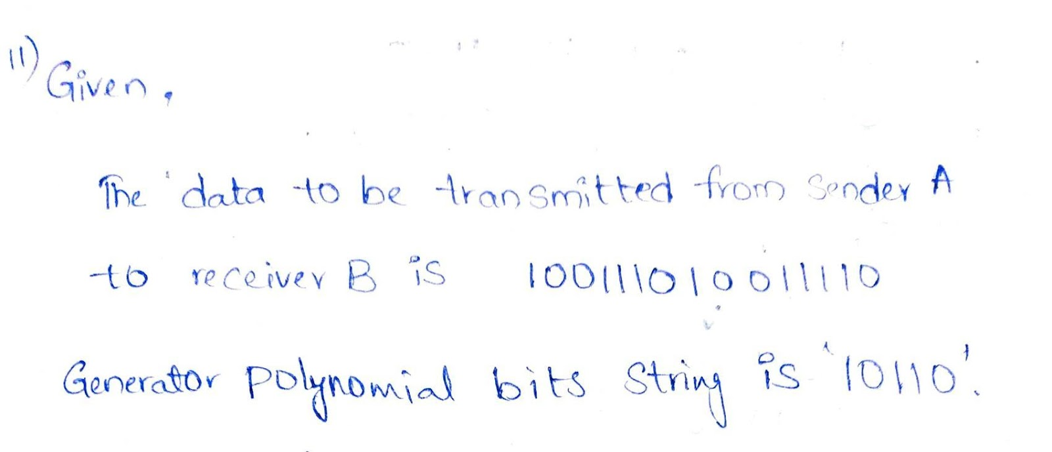

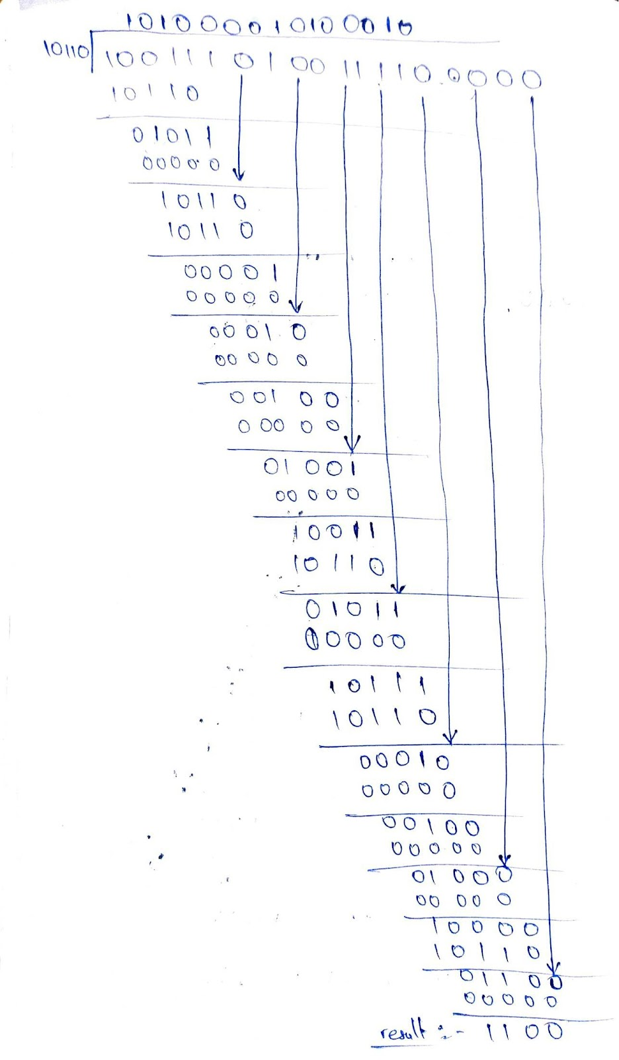

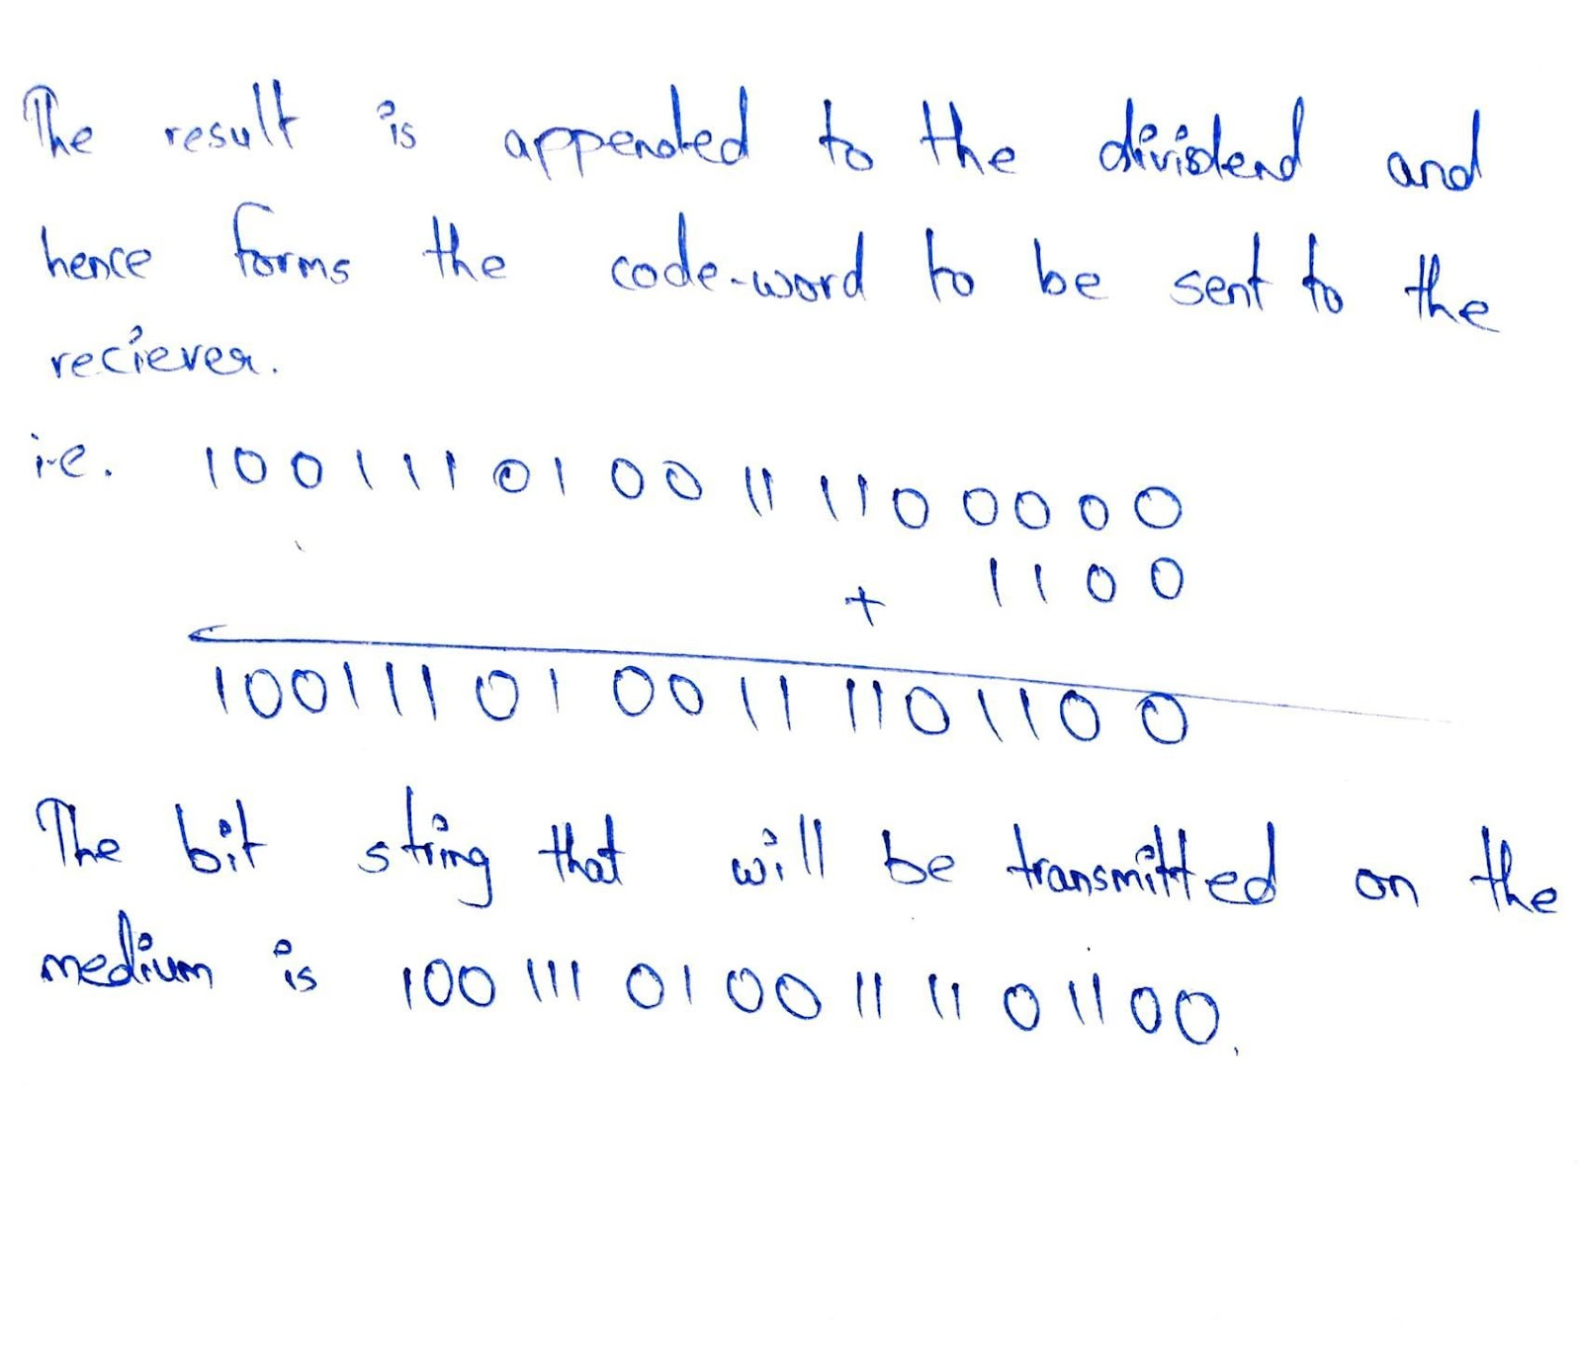

**12.**Consider the following network Figure 1. With the indicated link costs, use  Dijkstra’s shortest-path algorithm to compute the shortest path from u to all  network nodes. Show how the algorithm works by computing a table.

2v3w 5 

u 24 z 

14 

x3 

1y

***Figure 1***

**13.**Let g1(x) = x + 1 and let g2(x) = x3+ x2+ 1. Consider the information  bits (1,1,0,1,1,1).

a. Find the codeword corresponding to these information bits if g1(x)  is used as the generating polynomial.

b. Find the codeword corresponding to these information bits if g2(x)  is usedas the generating polynomial.

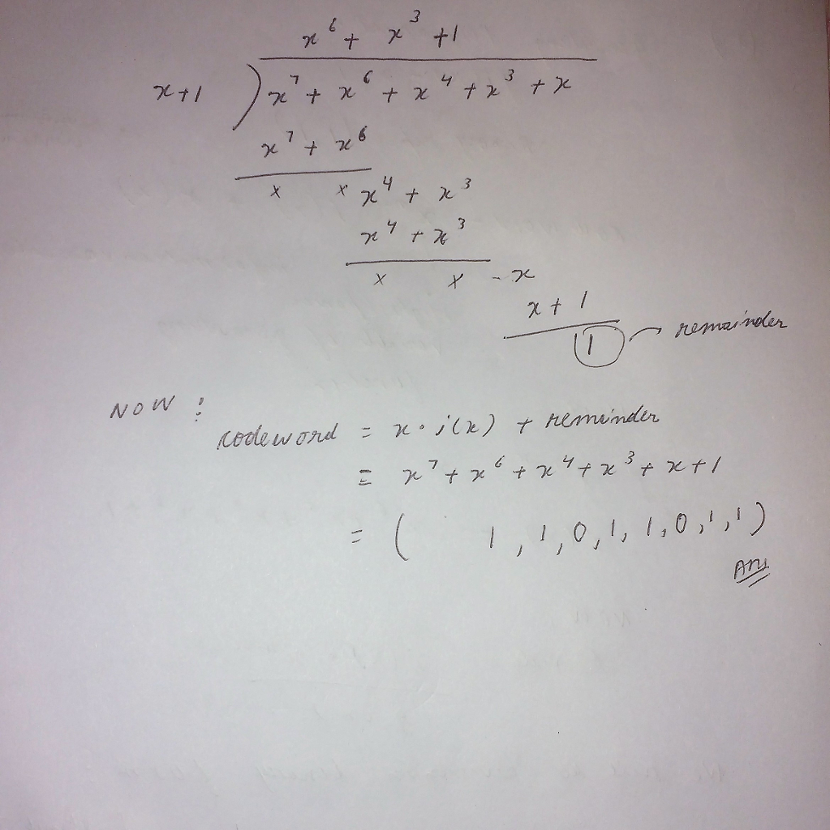

**14.**Consider the 7-bit generator, G=10111, and suppose that D has the value  1010100001. What is the value of R? Show your all steps to have result.

Given,

G=10111

D=1010100001

when writing G in polynomial form, the highest power is 4

so r=4

adding 4 extra bits at the end of D = 10101000010000

After dividing D with G we get remainder 1111

so, r = 1111